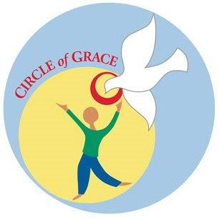
Circle of Grace©

Circle of Grace© is a faith-based safe environment curriculum that helps to form and educate children and youth about the value of positive relationships with God and others. It teaches children and youth how to identify and maintain appropriate physical, emotional, spiritual, and sexual boundaries; recognize when boundary violations are about to occur or have occurred; and demonstrate how to take action when boundaries are threatened or violated.

Adults assist children and young people to recognize God’s love by helping them understand that each of us lives and moves in a Circle of Grace. You can imagine your own Circle of Grace by putting your arms above your head then circling them down in front of your body, including side to side. This circle holds your very essence in mind, heart, soul and sexuality.

The Diocese of Peoria has chosen Circle of Grace© as a safety and prevention training curriculum for its schools and parish religious education programs. We all know a parent is a child’s first teacher! God has a vision for healthy relationships where all are respected, cared for and loved.

Circle of Grace© is not a sexuality education program. It provides a spiritual framework that will encourage parent-child communication, including sexuality.
There are grade-specific Parents First newsletters available to assist you in these conversations.

Thank you for partnering with us to keep kids safe!

Sincerely,

