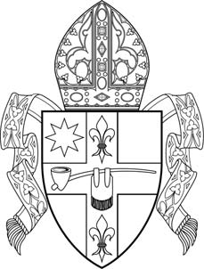
Catholic Diocese of Peoria
412 NE Madison Avenue Peoria IL 61603

Communication Policy (C-410)

It is the policy of the Catholic Diocese of Peoria to maintain an atmosphere of trust, openness and cooperation with the members of our Diocese regarding any matter involving the Sexual Abuse Policy. Furthermore, it is the goal of the Diocese to be continually committed to promoting a safe environment in all Catholic institutions and organizations throughout the 26 counties.

- All information regarding the Diocesan Sexual Abuse Policy, procedures, safe environment programs, civil and diocesan authorities will be posted on the diocesan website: www.cdop.org.

- The safe environment program will be advertised and promoted though the diocesan monthly mailings, parish bulletin announcements and brochures to be made available in every parish in the Diocese. Contact information will include the Diocesan Chancellor, Victim’s Advocate, Illinois Department of Children and Family Services and will be made available in all brochures.

- The safe environment program schedules are available through local diocesan parishes, schools and agencies.

- The Diocesan newspaper, The Catholic Post, will publish the sexual abuse policy on a regular basis.

- The Bishop of the Catholic Diocese of Peoria will hold a press conference (secular media and Diocesan media) or issue an official statement in the event that a new program is developed related to the Sexual Abuse Policy.

- A press release will be distributed to the secular and Diocesan media when a priest, religious or lay employee of the Diocese has been removed because of credible allegations of sexual abuse of a minor. If an interview is requested by a member of the media, the Director of Communications will act as the Diocesan spokesperson.

- Press releases and/or press conferences will occur for the purpose of communicating the on- going developments of the case. At the end of the investigation, the Diocese will release its findings and status of the person(s) involved.

- The person(s), parish and/or school involved will be offered appropriate counseling from a behavioral health provider.

- A Diocesan pastoral report will be released to all Catholic households in the Diocese of Peoria. The goal of the report will be to highlight the past work of the Diocese, the Diocesan finances, including any legal settlements and to promote any future projects.

