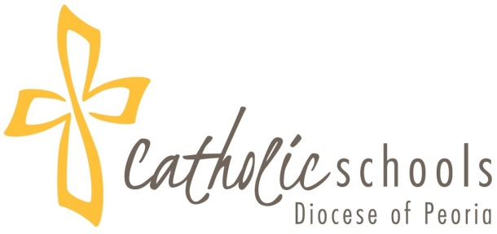

Diocesan Religion Curriculum
Domains to be Addressed at each Grade Level

Christian Anthropology: Students will come to understand who and what the human person is, as a rational creature made in the image and likeness of God (Genesis 1:27).

Creed/Beliefs: Students will understand, believe in, and proclaim the Triune God revealed in Sacred Scripture and Tradition, creation, and human experience.

Revelation (Sacred Scripture and Sacred Tradition): Students will be able to read, comprehend and articulate salvation history as conveyed in God’s revelation.

Church (Ecclesiology/History): Students will understand and appreciate the mystery of the Church as expressed in its origin, history, hierarchical structure, marks, charisms, and the lives of the saints.

Liturgy/Eucharist: Students will understand and celebrate the liturgy of the Church as expressed through the liturgical year and epitomized in the Eucharist, the source and summit of the Christian life.

Sacraments: Students will understand and participate in the sacraments as efficacious signs of God’s grace, instituted by Christ and entrusted to His Church.

Prayer and Spirituality: Students will develop a personal relationship with Christ by learning and practicing the various forms of Christian prayer and through self-surrender to God.

Christian Life: Students will understand and participate in the life of the Church as lived through worship, sacramental life, community service, culture, evangelization and missionary endeavors.

Morality: Students will understand and embrace the moral teachings of the Church through a life marked by love for God, conversion, personal integrity, social justice, and love of neighbor.

Vocations: Students will understand and fulfill their baptismal call by discerning and living a specific vocation in the service of Christ and His Church.

